Cambridge University Library Map Department

Information Sheet 5C

Searching for Maps and Atlases in iDiscover

This text is also available as an iDiscover Quick Guide at http://libguides.cam.ac.uk/idiscover

Additional information specific to Cambridge University Library Map Collection can be found at www.lib.cam.ac.uk/collections/departments/maps/finding-maps
Tips on finding books on cartography and gazetteers can be found at www.lib.cam.ac.uk/collections/departments/maps/map-department-catalogues/books

Some of the cartographic materials – maps and atlases – held in Cambridge libraries are listed in iDiscover. However, many are not and may just be listed in card catalogues or other finding aids that are accessible only within the library concerned. In the University Library, for example, most of the collection of 1.2 million maps can only be accessed via the card catalogue and other paper finding aids and cannot be found in iDiscover.

In iDiscover there is usually more than one way to construct a search. Different search strategies will use different parts of the catalogue record and so may produce subtly different results, so it is usually worth trying more than one type of search.

If you can’t find what you are looking for, ask a librarian!

We will discuss below:
  - Advanced Search (Recommended!)
    - Searching for maps and atlases of a particular Place
    - Searching for maps and atlases of a specific Type
    - Searching for maps and atlases at a specific Scale
  - Sorting Results by Date
  - Simple Search
  - Searching for World Atlases
  - Subject Search Terms

Note: For the purposes of this guide the term ‘maps’ includes atlases.

ADVANCED SEARCH:

‘Advanced Search’ is recommended for finding cartographic materials within iDiscover. This is primarily because when searching for maps people are often looking for maps of a particular area rather than for a specific item of which the title / author are known (if you do have this information it may be useful to look at some of the other Quick Guides at http://libguides.cam.ac.uk/idiscover).

Searching for Maps and Atlases of a Particular Place:

Click on ‘Advanced Search’:

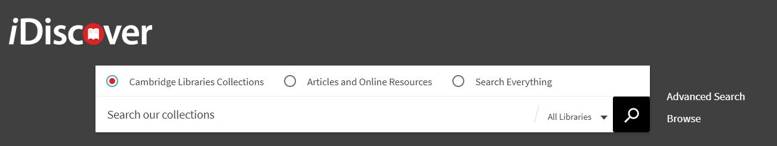

- Limit your search to ‘Cambridge Libraries Collections’
- If you want to search the collections of a particular library select the relevant library from the ‘Library’ drop down list on the left.
- To search for maps of a specific area, select ‘Subject’ from the drop down menu on the left, ensure the central box is set to ‘contains’, and in the search box type the area required followed by the word ‘maps’:

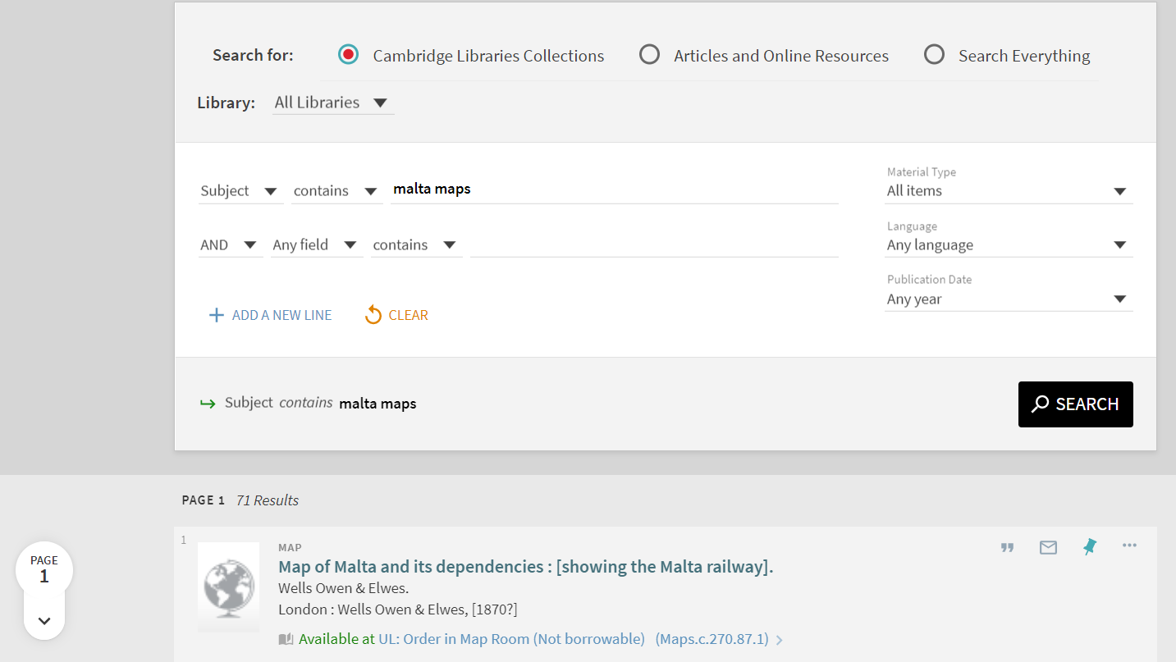

- Click on to retrieve your results.

Note: Unless you have selected a specific library, this will search across all Cambridge libraries and collections (print and electronic) and Apollo, the Cambridge institutional repository. Selecting ‘Articles and Online Resources’ or ‘Search Everything’ will also find online images of maps in a selection of external databases.

Note on World Maps: If you do a subject search – as shown above but with the second column set to “is (exact)” – for world maps you would find maps of the world BUT NOT world atlases. There is a section towards the end of this document on searching for world atlases.

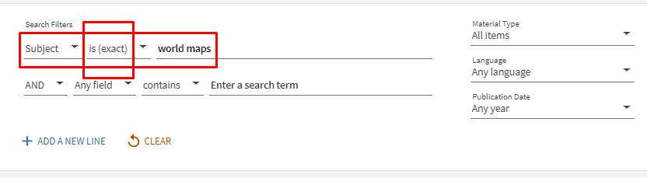

Note: If you don’t find anything suitable it is also worth doing an ‘And - Any field - contains’ search for your place name, with ‘maps’ as your only subject search word:

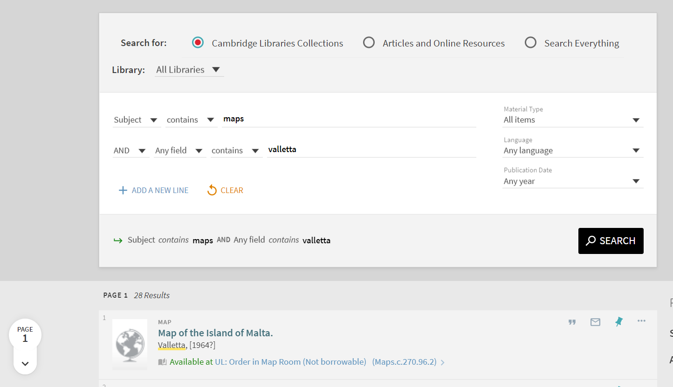

This is most effective for smaller places that are not likely to be a place of publication.

Searching for Maps and Atlases of a Specific Type:
To find maps of a particular type – geology or soil maps, for example, or maps published before 1800, or facsimiles – use one of the following search strategies.

1) Add additional search terms to your ‘Subject’ search box. Some of the more commonly used search terms are listed below; they can be combined with a place name or searched instead of a place name if you are only interested in, e.g., geological maps:

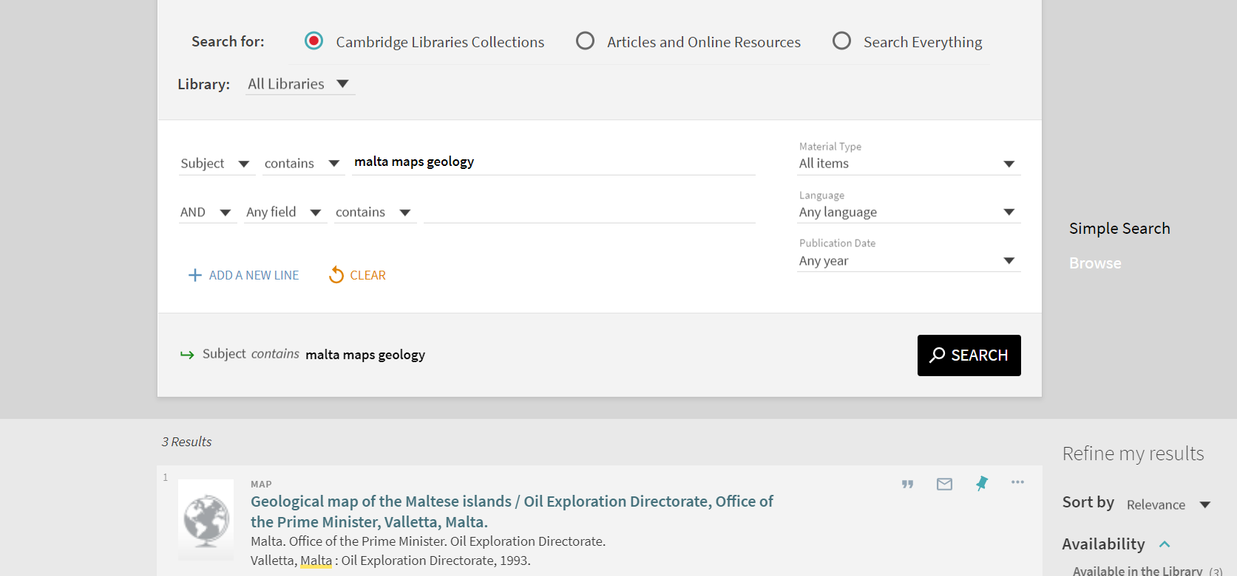

- Click on to retrieve your results.

2) Or, on the next line of search boxes, ensure that the drop down options are set to ‘And’ and ‘Any field’ and ‘contains’ and type subject (or title, author, publisher, additional place name, etc.) words into the corresponding search box:

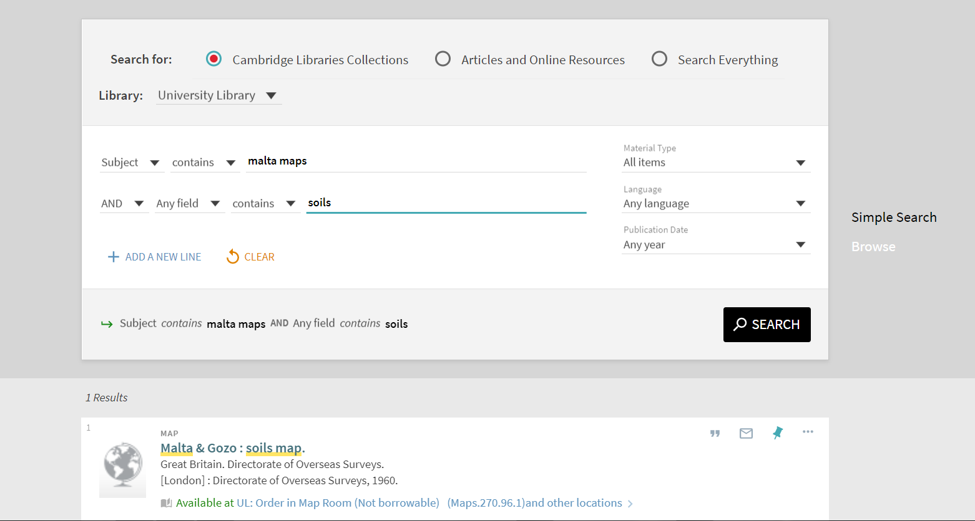

- Click on to retrieve your results.

3) Or, use the ‘Refine my results’ options on the right side of the results screen. In the ‘Subject’ section of the ‘Refine my results’ panel you can restrict your results to, for example, specific areas, e.g. Valletta, or to type of map, e.g. Roads (these terms are taken from the Subject Headings in the catalogue records).
Note: Click on the ‘Show more’ label at the bottom of the list to see all the refining options
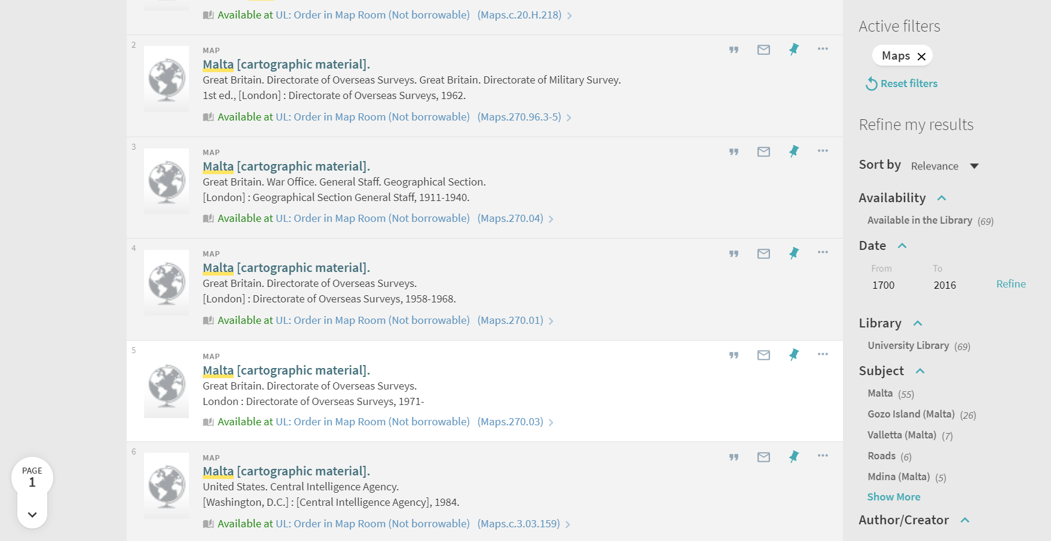
- For more details on refining and expanding searches see Quick Guide: Refining, expanding and ordering your results http://libguides.cam.ac.uk/idiscover
- You might also find Quick Guide: Advanced searching methods useful – see http://libguides.cam.ac.uk/idiscover

Searching for Maps and Atlases at a Specific Scale:
Catalogue entries for most (but not all) maps and atlases drawn at one or two scales include a scale statement in the form of a representative fraction, such as 1:50,000. To search for such items do an ‘Any field - contains’ search for ‘50000’, etc. (i.e. search for the number after ‘1:’, excluding commas and spaces), plus the word ‘maps’ as a subject, with or without a place name:
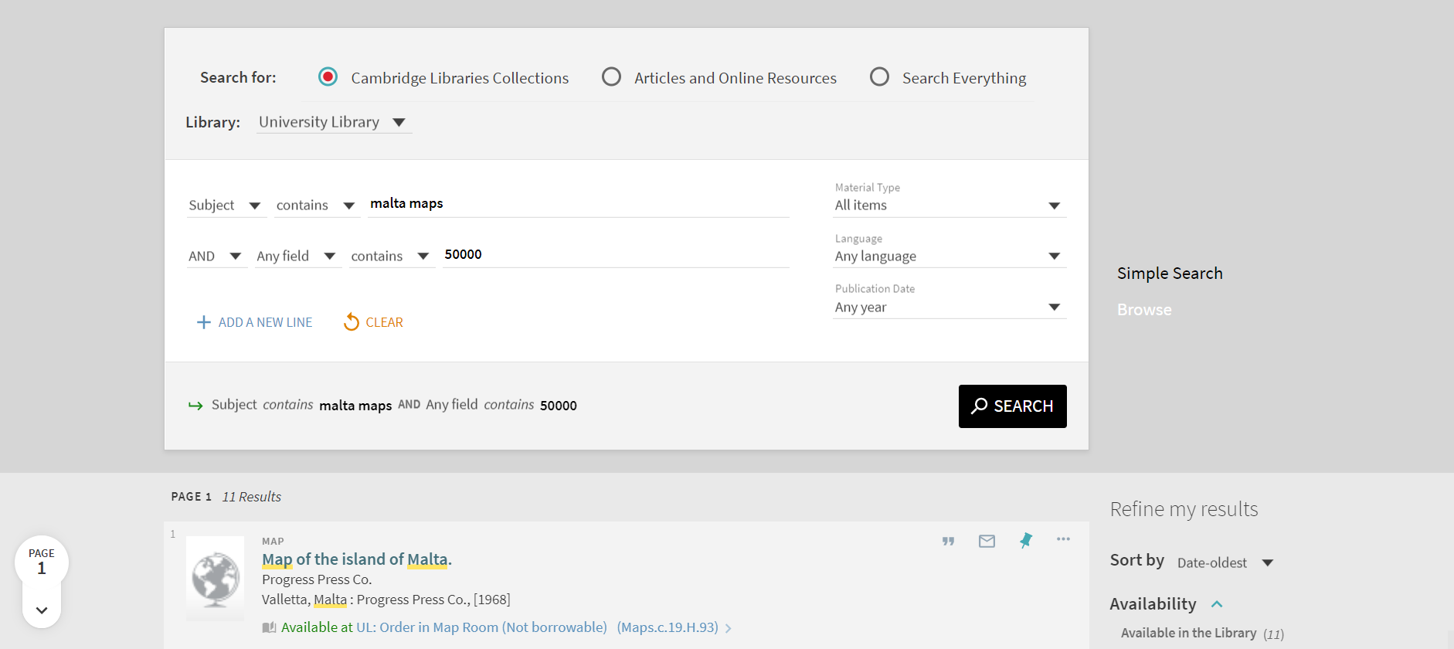
- Click on to retrieve your results.

Note: Catalogue entries for maps and atlases drawn at more than two scales, or with no, or an unknown scale, may include scale statements such as: ‘Scale not given’; ‘Scale indeterminable’; ‘Scales differ’; ‘Not drawn to scale’ – or there may be no scale statement at all.
SORTING RESULTS BY DATE:
You will probably then want to sort the results into Date Order:
- Use the ‘Sort By’ feature on the right of the search results screen:

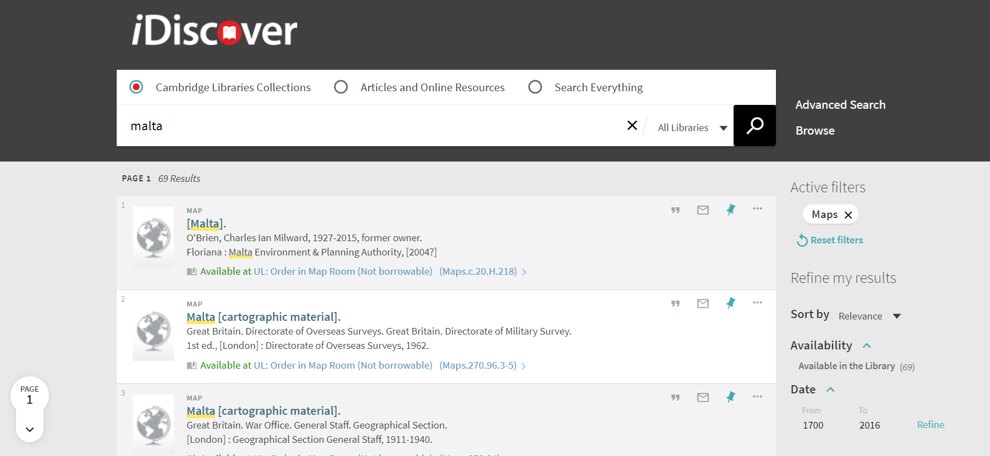

- Sort the results by ‘Date – oldest’ to see the oldest entries first:
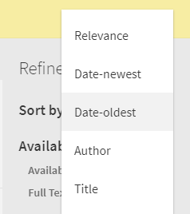
Note: Electronic versions come first when you sort by Date-oldest, so you can also limit to ‘Available in the Library’ which will give only cartographic items which are physically available in a library somewhere in Cambridge.
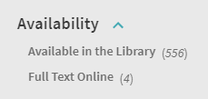
Note: Early printed items which have uncertain dates may also come at the top of your list when sorted by Date-oldest; you can avoid this by refining your set of results further by date. The system will give default dates which you can search between, based on the results of your search. You can refine down to a single year.
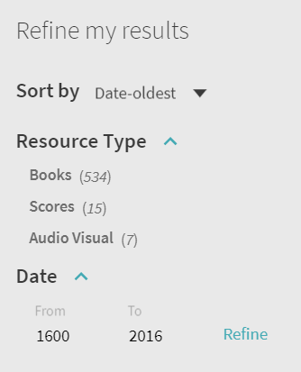

SIMPLE SEARCH:

Conducting a Simple Search will produce similar results to an Advanced Search but there will be some differences. Try both to make a thorough search of the collections.
- Select ‘Cambridge Libraries Collections’ and type your search term in the ‘Search our collections’ box:

- Most often you will be looking for a map of a particular place so your search term might just be the name of that place e.g. Cambridge:

- But if you are looking for a specific map then you can enter title words, cartographer, etc. here. If you are looking for a particular title then use “…” around the title.
- If you only want to search the collections of a particular library select the relevant library from the ‘All libraries’ drop down list on the right.
- Click on to retrieve your results.

Note: This will search for books (printed and electronic), other physical library content and Apollo, the Cambridge institutional repository. Selecting ‘Articles and Online Resources’, or ‘Search Everything’, will also find online images of maps in a selection of external databases.

- For more details on simple searching, see: Quick Guide: Quick searching http://libguides.cam.ac.uk/idiscover

- Use the ‘Refine my results’ options on the right side of the results screen:
- Go to the ‘Resource Type’ area.
- Select ‘Maps’ (this include atlases)
- For more information see Quick Guide: Refining, expanding and ordering your results http://libguides.cam.ac.uk/idiscover.

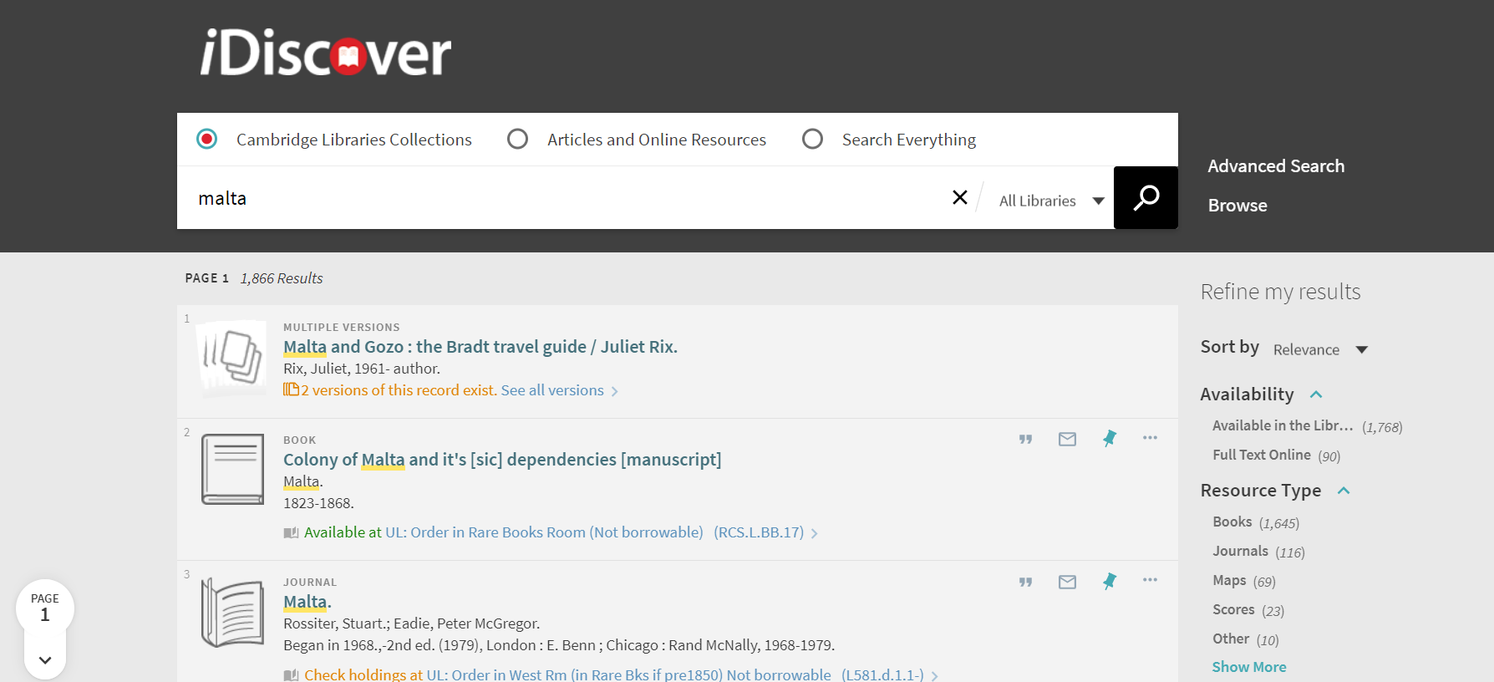

SEARCHING FOR WORLD ATLASES:
To find World atlases in iDiscover it is best to do a browsable Subject search. This is because catalogue records for World atlases contain no conventional ‘Place’ subject heading (though see above for searching for World Maps):
- Select ‘Cambridge Libraries Collections’
- Go to Browse:
- Select ‘Browse by Subject’ and type the word ‘atlases’ in the Search Box:
- Click on to retrieve your results.

This will retrieve a list of subject headings beginning with the word ‘Atlases’:
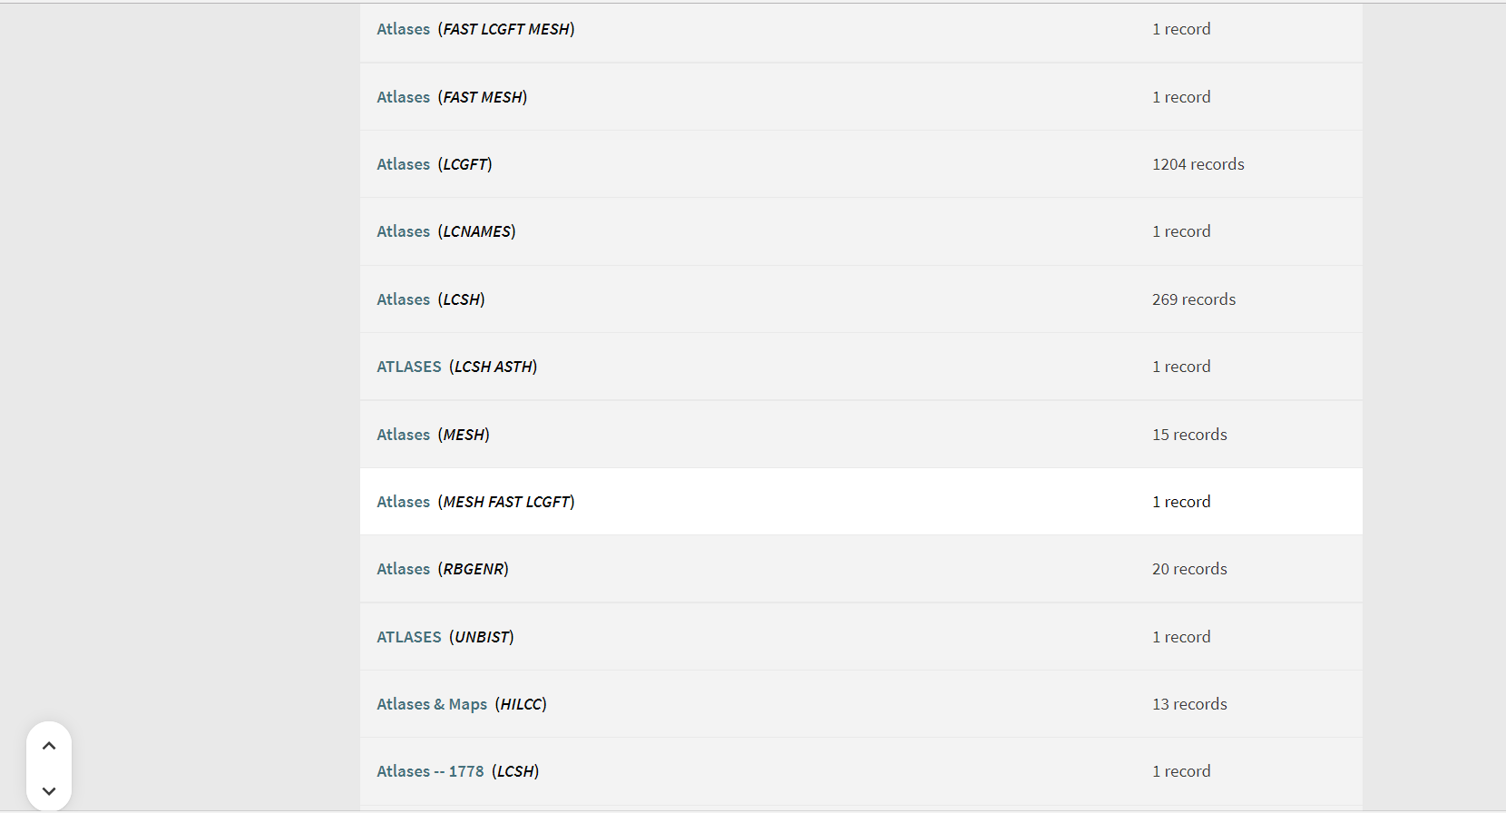
- Look for ‘Atlases (LCSH)’. Click on this to see World atlases published in the United States of America (you can largely ignore the ‘Atlases’ headings followed by other strange abbreviations!)

- If you want World atlases published in other countries add the name of the appropriate country (Australia, Belgium, Great Britain, Netherlands …) to the ‘Browse by Subject’ search box:

SUBJECT SEARCH TERMS FOR MAPS AND ATLASES OF A PARTICULAR TYPE:
Catalogue records will nearly always include subject headings which, for maps, will indicate the area covered by the map or atlas and, where appropriate, special characteristics such as topic (geology, soil, administrative) or type of map (e.g. facsimile).
In many Cambridge libraries, the terms used in these subject headings are taken from a restricted list known as Library of Congress Subject Headings (LCSH). They were devised in the USA, hence the American spelling of words like harbor.
A searchable list of LCSHs is available at:
http://authorities.loc.gov/cgi-bin/Pwebrecon.cgi?DB=local&PAGE=First
The list below includes a selection of headings most commonly used when looking for maps and atlases. They can be used in Subject searches (in Advanced Search, see above) with or without a place name.

It is best to start your search with general terms and then refine it by using more specific search terms if necessary. If you find an item that suits your needs, try searching on the subject terms present in the catalogue record for that item.
Also think, where appropriate, of substituting the word ‘maps’ with guidebooks – cycling and walking guidebooks, for example, often contain maps – or of dropping the terms maps / charts altogether.

Selected Library of Congress Subject Headings useful when searching for maps and atlases (Use ‘Subject’ search in ‘Advanced Search’)
early works maps | For maps and atlases (original and facsimiles) published before 1800
administrative maps
aerial views | For maps that depict places observed from the air
aeronautical charts
agriculture maps
archaeology maps
archaeological surveying maps
bathymetric maps
childrens atlases | For children’s atlases. If you want maps search for childrens maps
cities towns maps | For collections of maps (including atlases) of cities and towns, including worldwide collections. Combine with a place name – e.g. a country – for collections of city and town maps of that country
climate maps
cycling maps | Also try bicycle trails maps
facsimiles maps
geology maps
globes | For globes (and books about globes)
historical geography maps
history maps
land use maps
manuscript maps
mental maps
nautical charts
outline base maps | For outline and base maps
physical maps
pictorial maps
pictorial works maps
planning maps | You could also add the terms: city ; highway ; regional as appropriate
railroads maps
remote sensing images
remote sensing maps
roads maps
soils maps
topographic maps | For maps with topographical information (relief, settlements, etc.) at more detailed scales of ca. 1:200,000 or larger. Use with caution since some useful maps (and, e.g. town plans) may be excluded
tourist maps
transportation maps | For maps showing a variety of transport modes. For specific transport types search for: railroads ; roads ; air travel ; harbors ; waterways ; rural transportation ; subways ; urban transportation ; etc plus maps
walking maps | Try also trails maps and hiking maps
weather maps
world maps  [search as an exact phrase] | For maps of the whole world. See also section above on ‘Searching for World Atlases’

Note: Tips on searching iDiscover for books on cartography can be found at https://www.lib.cam.ac.uk/collections/departments/maps/map-department-catalogues/books
Note: Not all maps can be found on iDiscover. The Map Department of Cambridge University Library http://www.lib.cam.ac.uk/collections/departments/maps has a huge map collection much of which is only catalogued in a card catalogue that is not available remotely. More information on finding maps in the University Library can be found at http://www.lib.cam.ac.uk/collections/departments/maps/finding-maps
Note: Cataloguing standards inevitably change over time and may not be the same across all libraries. It is always worth, therefore, after you have tried the search strategies described above, trying an ‘Any field’ (i.e. keyword) search, especially for smaller or more obscure place names.
Note: Also search ArchiveSearch, the University’s manuscripts and archives catalogue. To access the ArchiveSearch catalogue, go to https://archivesearch.lib.cam.ac.uk/ For help on using the catalogue see https://www.lib.cam.ac.uk/collections/departments/maps/finding-maps/archivesearch-catalogue and https://libguides.cam.ac.uk/ArchiveSearch/Home.

Note: Maps, atlases and most books on cartography in the University Library cannot currently be requested electronically; you will need to fill in a paper request form, probably in the Map Department’s reading room. To request cartographic materials held in other Cambridge libraries, contact the relevant librarian.

Note: A document listing the larger map collections in Cambridge can be found in Cambridge University Library Map Department’s Information Sheet 2A at http://www.lib.cam.ac.uk/collections/departments/maps/information-sheets

This Information Sheet is available online as a Word document at http://www.lib.cam.ac.uk/collections/departments/maps/information-sheets
© Cambridge University Library Map Department maps@lib.cam.ac.uk 6 October 2021

